Prepared by: Kevin Mehta

Important information highlighted on page  
**Bolded text should be bolded on page**  
Regular text.  
Diagrams and context  
Animation idea

**Speed, Velocity, and Acceleration**

* **Topics**
  + Introduction
    - Kinematics, one of the many topics in physics, is the branch of mechanics that is directly and only related to the motion of objects. It does not involve the forces that propel motion.
  + Scalars and Vectors
    - Scalars and Vectors are mathematical quantities used to describe the motion of objects.
    - Scalars are quantities that are only defined by magnitude
    - Vectors are quantities that are defined by not only magnitude but are also given a direction.
  + Distance and Displacement
    - Distance is a scalar quantity that refers to the collective movements of an object up until the object reaches its final destination.
    - Displacement is a vector quality that refers to singular change in the objects location from the starting point.
    - Diagram showing the difference between distance and displacement, refer to <http://www.physicsclassroom.com/class/1DKin/Lesson-1/Distance-and-Displacement>  
       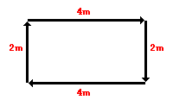  
      The distance from the bottom left corner to the top right corner would be 4m + 2m = 6m (taking either route)  
      The displacement from the bottom left corner to the top right corner would be 42 + 22 = d2 = sqrt(20)
  + Speed and Velocity
    - Speed is a **scalar** **quantity** that only tells us how fast an object is moving
    - Velocity is a **vector quantity** that tells us the rate at which an object changes its position.
    - The zero velocity dilemma: If a person walks from their house to the park and back, it would result in a zero velocity because the change in position is zero.
  + Acceleration
    - Acceleration is a **vector quantity** that is given by the rate at which an object changes its velocity.
    - Animation that shows the difference in acceleration between cars, refer to <http://www.physicsclassroom.com/mmedia/kinema/acceln.cfm>  
       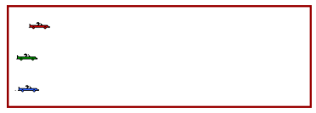  
       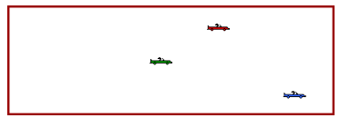
    - Diagram that shows the acceleration due to gravity (9.81m/s2 towards the Earth), <http://www.physicsclassroom.com/class/1DKin/Lesson-5/Acceleration-of-Gravity>   
       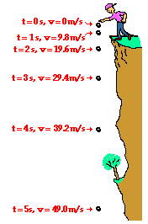  
      Note that the velocity downwards increases due to the constant downwards acceleration (caused by gravity)
* **Equations**
  + Speed and Velocity

 

* + Acceleration



* + The four major kinematic equations

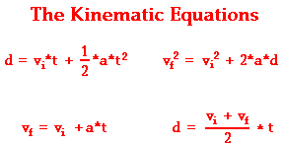

**Forces**

* **Topics**
  + Introduction
    - A force is a push or pull that acts on an object. A force is exerted on an object, i.e. an object cannot push or pull itself.

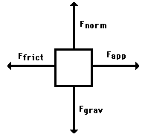

* + - The 4 most common forces that act on an object on the Earth are:
      * Normal Force
      * Friction Force
      * Gravitational Force (usually 9.81m/s2 downwards)
      * Applied Force
  + Newton’s First Law
    - An object at rest stays at rest and an object in motion stays in motion with the same speed and in the same direction, unless met by a force from any angle.
    - When an object is at rest, velocity = 0 therefore the object stays at rest
    - When an object is in motion, v != 0 and if acceleration = 0, the object will continue moving at the same velocity.
  + Newton’s Second Law
    - The net force acted upon an object is equal to the object’s acceleration times the object’s mass.
    - Fnet **=** ma
  + Newton’s Third Law
    - Newton’s third law states that for every action, there is an equal and opposite reaction.

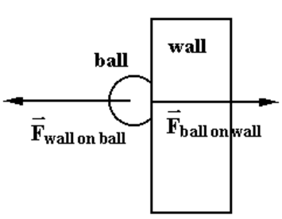

**Motion**

* **Topics**
  + Motion and Kinematics
    - Projectile Motion
      * Projectile motion is the motion of an object moving in two dimensions under the influence of gravity.
      * Free-fall is an example of projectile motion where the motion was restricted to one dimension
      * Examples: Baseballs, footballs, bullets, etc.
      * Diagram that shows an example of projectile motion and the appropriate calculations at that point.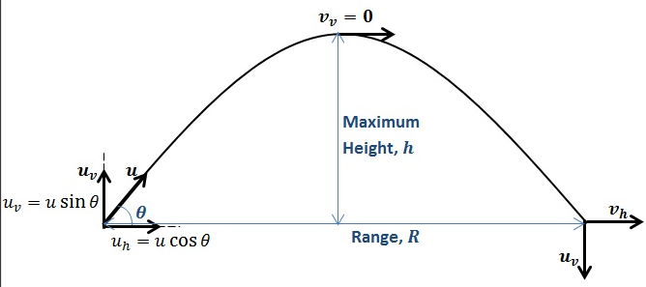
    - Important Information
      * At any point in the projectile’s trajectory, it is imperative to calculate the horizontal and vertical velocities noted by  
         
      * When the projectile is at its maximum height, the velocity will be 0
      * Any motion in which one component of the acceleration is zero, and the other component of acceleration is constant, the object follows a parabolic trajectory.
  + Motion and Dynamics
    - Forces and motion
      * Gravity acts only in the vertical **(y)** direction.
      * Hence the x component of the motion is in dynamic equilibrium (no net forces).
      * The net force in the **y** direction acts vertically downwards (as gravity).  
         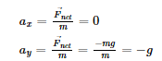
      * A projectile launched horizontally from a height **h** reaches the ground at the same time as a projectile that was vertically dropped from the same location. This is because the vertical motion of both projectiles is identical. Animation that shows a ball at some height thrown and dropped (must reach ground at the same time)